Milestone 7

**Team**: DR.AA

**Team Members**:

Dongjie Zhang,

Richard Morley,

Nha Thao Amanda Tran,

Avery Olson

**Project Tracker**: For this project we used Trello in order to keep track and organize the functions we placed in our app. We also used trello to design our sprints.

<https://trello.com/draa3>

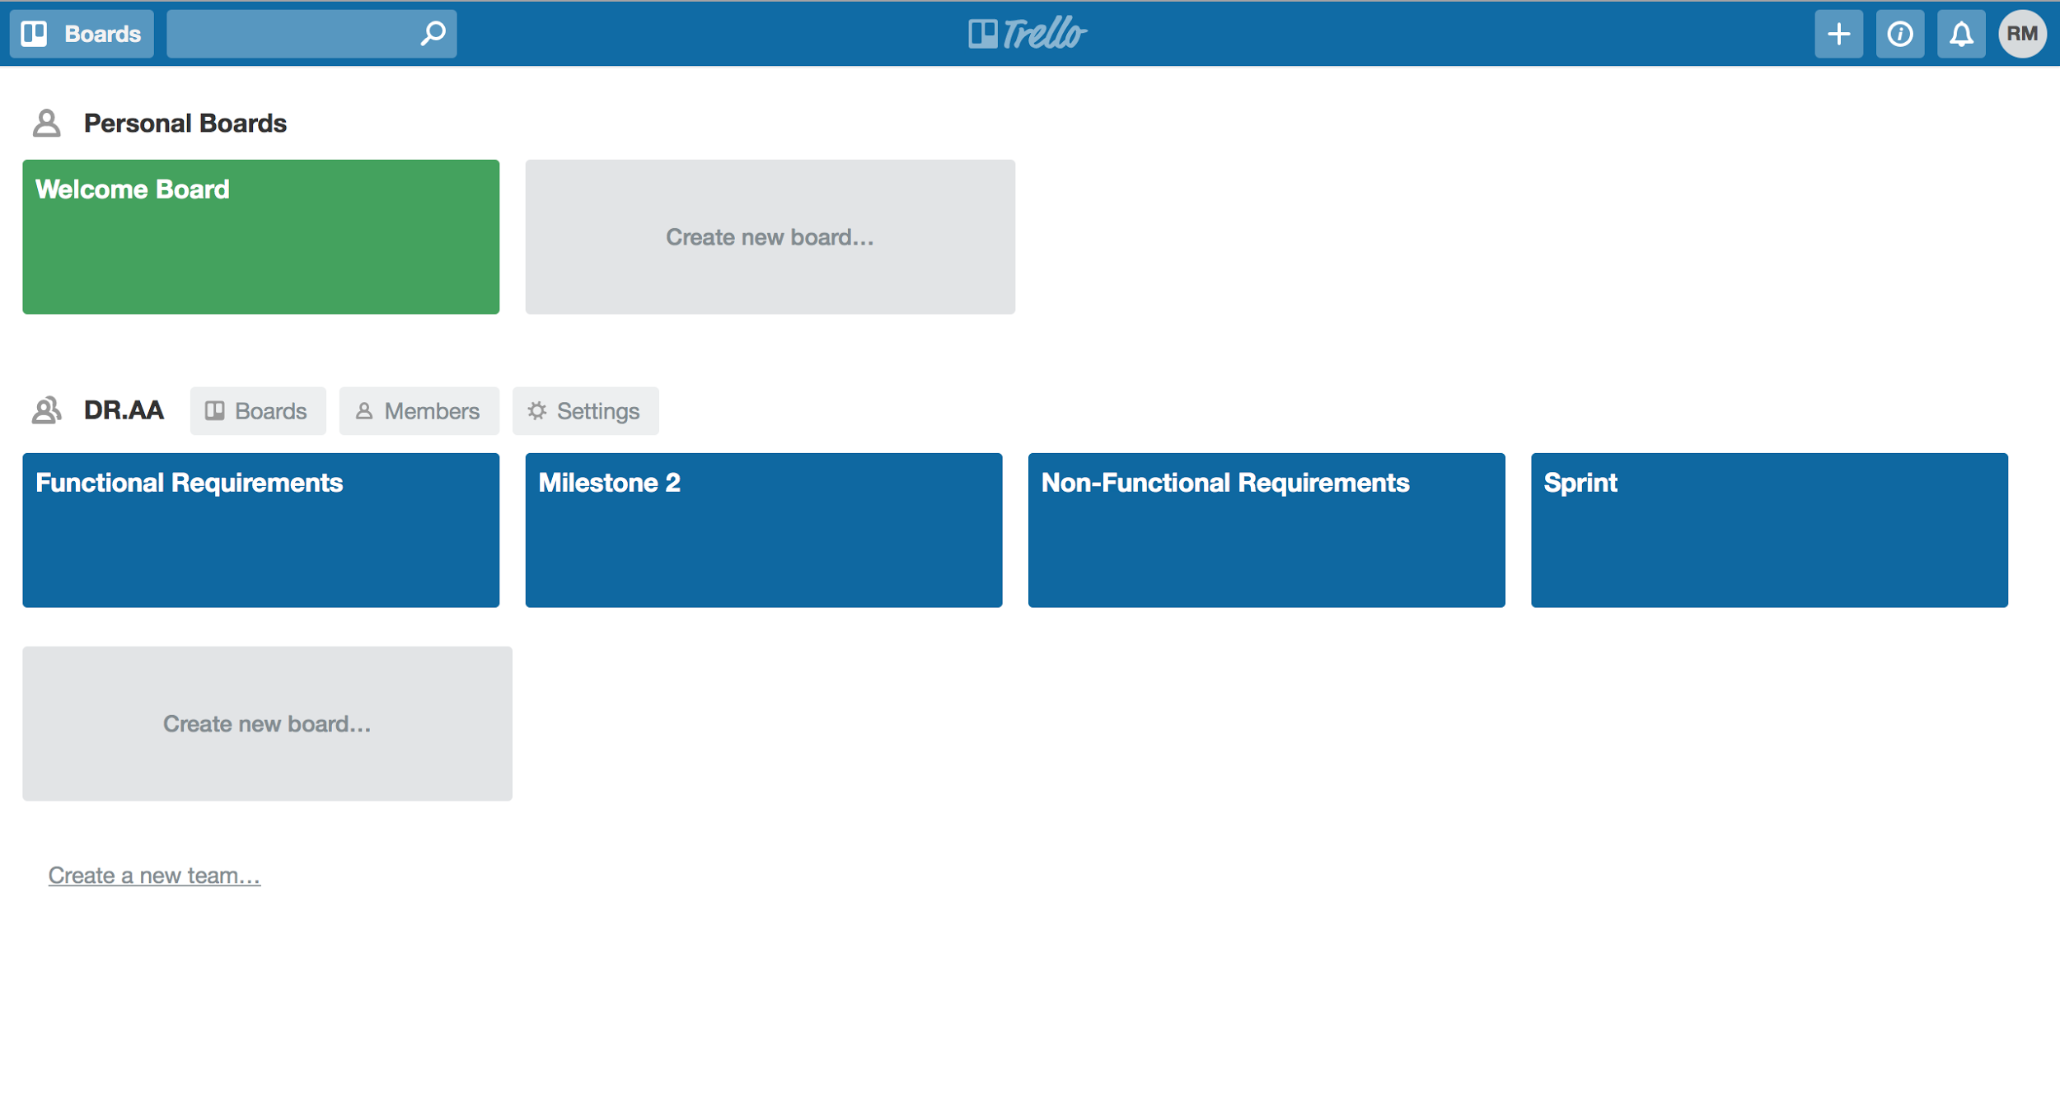

**Github Repository**: <https://github.com/rjmorley/DR.AA>

**Github Screenshots**: Note*** We wrote all the code on one computer during our group meetings, and so we only committed the milestones to Github and the final source code.

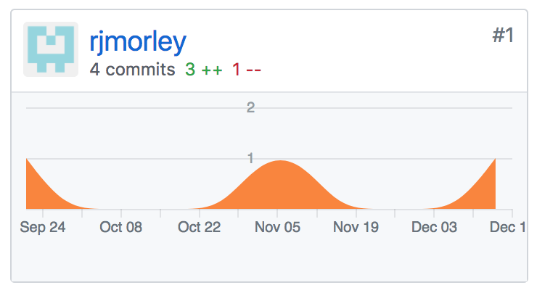Richard Morley

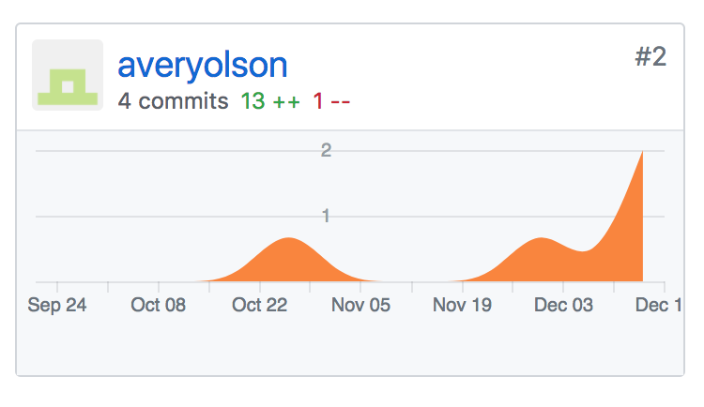Avery Olson

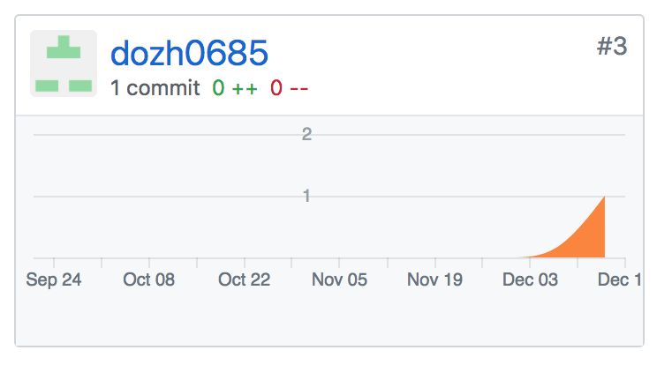Dongje Zhang

**Deployment**: Our app can be tested by running the source code in Xcode and using the built in simulator to see it live.